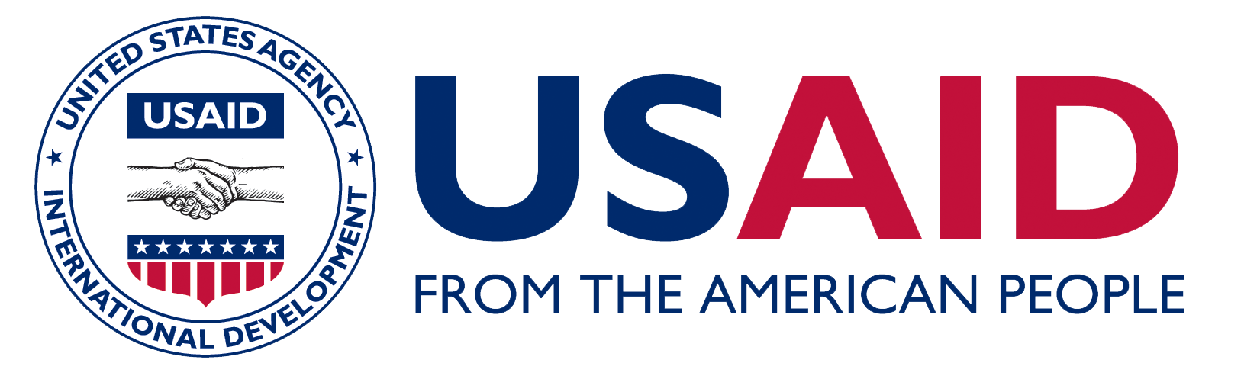

CHILDREN’S LEGAL

BUREAU INC.

Barangay Officials of Lawaan II, Talisay Rescue a

Minor from Trafficking

|  |  |
| --- | --- |
| ***February 2017***    *Even with a successful rescue, the three barangay officials still feel apprehensive realizing that there are still many human traffickers roaming around unidentified. These people can recruit more children not only within their barangay but also in the neighboring barangays. As barangay officials, they are face with these challenges but they are committed to act in their capacity as barangay officials.*  ***Telling Our Story***  *U.S Agency for International Development*  *Washington, DC 20525-1000*  *http://stories.usaid.gov* | A 14-year old girl was rescued by the team of barangay officials from Lawaan II. The barangay officials who led the rescue were Barangay Chair Buenaventura R. Pelonio, Barangay Councilor Jackie Sarona who heads the Committee of Women and Children and also a trained Para Social Worker and Joan Cabalda, barangay secretary.  A girl accompanied by a former trafficked victim reported to the barangay that her 14-year-old younger sister has been in the hands of a gay suspect. According to the former trafficked victim, the suspect was recruiting young girls by promising that they will earn lots of money if they will join. After they recruitment, the girls are forced to take drugs and then used for prostitution. In line with the protocol of reporting, the barangay officials immediately informed the City Social Welfare and Development Office (CSWDO) and Philippine National Police (PNP) about the report, the description and the hideout of the suspect. The report coincided with the description of the suspect and the area already under surveillance by the PNP and the Children’s Legal Bureau, Inc. (CLB).  Because of the appeal of the victim’s older sister who was worrying her health and safety, they immediately rescued her using the barangay vehicle without waiting for the PNP. A successful rescue was done at 12 midnight, after which, they immediately brought the girl to the CSWDO who referred her to a temporary shelter in Cebu City managed by DSWD Region VII. The girl was found to already be infected with STD and currently under medical treatment.  The three barangay officials realized that they can do something in their capacity to stop or prevent possible child trafficking and planned to involve all their barangay councilors and community watch groups to monitor their respective sitios. They also plan to organize their young people for continuing information drive.  **Empowering Communities and Building Partnership on**  **Anti-Trafficking in Person in Cebu**  **Philippines** |